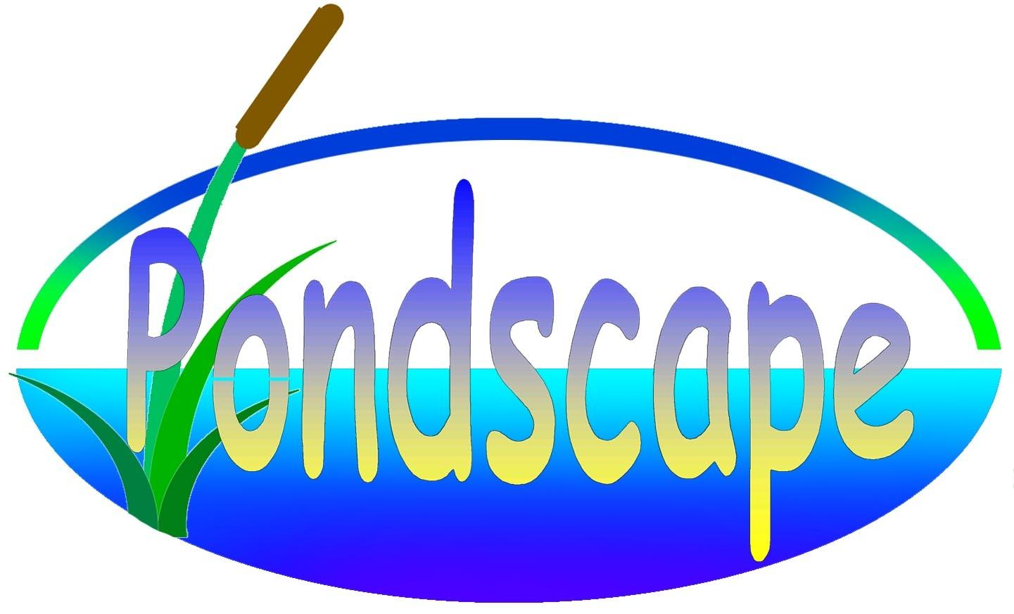
Meeting Follow up Committee Pondscape -
20 November 2009

Date: 20/11/2009
Venue: Royal Belgian Institute of Natural Sciences, Vautierstraat 29, 1000 Brussels
Convenor: Koen Martens (Coordinator; Royal Belgian Institute of Natural Sciences)
Participants: - Aline Vanderwerf: Belspo
- Hélène Quidé: Regionaal Landschap Meetjesland
- Thierry Demol: Service public de Wallonie
- Hendrik Segers: Royal Belgian Institute of Natural Sciences
- Luc Crevecoeur: Provinciaal Natuurcentrum, Bokrijk
- Thierry Vercauteren: Provinciaal Instituut voor Hygiëne
- Paul Haustraete: Regionaal Landschap Vlaamse Ardennen
- Christian Mulders: Agriculture Walloon administration
- Thierry Kinet: Natagora
- Louis-Joan Lemmer: Stad Hasselt, Dienst Leefmilieu
- Koen Martens: Royal Belgian Institute of Natural Sciences
- Els De Roeck: Royal Belgian Institute of Natural Sciences
- Tom De Bie: Catholic University of Leuven
- Steven Declerck: Catholic University of Leuven
- Jeroen Van Wichelen: University of Ghent
- Robert Mandiki: University of Namur
- Bertrand Losson: University of Liège
- Yannick Caron: University of Liège
- Leo Vanhecke: Plantentuin Meise
Excused: Olivier Dochy (INBO), Machteld Gryseels (Leefmilieu Brussel – BIM), Anne Loncin (CRIE de la Forêt d'Anlier), Henk Schaut (Regionaal Landschap IJzer & Polder vzw), Gerald Louette (INBO), Arnaud Laudelout (Natagora), Jos Coteur (Natuurpunt Hasselt-Zonhoven), Rik Jacobs (Conservator Tommelen..), Marc Thirion (SPW), Guido Waajen (Waterschap Brabantse Delta), Gaby Verhaegen (VMM), Kathleen Vandergucht (University of Ghent), Henri-Michel Cauchie (CRP - Gabriel Lippmann), Luc Denys (INBO), Wim Vyverman (University of Ghent), Luc De Meester (Catholic University of Leuven), Dirk Ercken (Catholic University of Leuven), Patrick Kestemont (University of Namur), Marc Herremans (Natuurpunt), Boudewijn Goddeeris (Royal Belgian Institute of Natural Sciences), Pieter Vanormelingen (University of Ghent), Maria Villena Alvarez (University of Ghent), Annick Castiaux (University of Namur), Kevin Morelle (University of Namur), Dirk Bauwens (INBO).
Report: Els De Roeck, Heidi Courard
Agenda: see Annex 1

The PONDSCAPE partners presented their work to the Follow-Up Committee members. After each presentation the Follow-Up Committee members were given the opportunity to formulate suggestions. The program of the meeting was as follows:

13:00 – 14:00 Lunch (Wifi room)

14:00 – 14:10 Introduction to PONDSCAPE (K. Martens)
14:10 – 14:30 Tommelen case study (T. De Bie)
14:30 – 14:50 Pond management (E. De Roeck)
14:50 – 15:10 Microbial ecosystem functions (H.M. Cauchie)
15:10 – 15:30 Socio-historical survey (K. Morelle)

15:30 – 15:45 Coffee / tea break (Wifi room)

15:45 – 16:00 Pollutants in ponds (R. Mandiki)
16:00 – 16:20 Intermediate hosts of Fasciola hepatica (Y. Caron)
16:20 – 17:00 General discussion

Unfortunately, two speakers (H.M. Cauchie and K. Morelle) could not attend the meeting due to unforeseen personal circumstances, their talks were cancelled

The presentations that were presented will be made publicly on the Pondscape website (www.pondscape.be).

Several interesting remarks and suggestions were given with reference to the material presented in the presentations:

- It was suggested to measure the nutrients in the ponds of Tommelen also in winter, as to look at nutrient cycles and nutrient depletion.

- A general applied management technique is the dredging of a pond during two different phases: at each moment only half of the pond is dredged to reduce pronounced loss of inhabiting organisms. However, this technique is not as efficient as dredging the whole pond at once. Firstly, the cost of having to dredge a pond twice is much higher, and secondly, nutrients are less efficiently removed compared to a single dredging activity. It was concluded that one has to look at the situation of the pond itself; e.g. if a pond is strongly isolated and contains very rare species, one can consider not to dredge the total pond at once. In our current experiment, we also investigate the effect of re-inoculation of a part of the vegetation layer. This could be an efficient and inexpensive alternative.

- A suggestion was made that we could, with the data available from the project Pondscape, make a pond typology for the Water Framework Directive. In reference to this, we could contact VMM (or even the minister if necessary).

- To improve management in the field, it was advised to work close together with institutions such as Regionaal Landschap or VMM in order to give them the information we have gathered and vice versa.

- Concerning the Fasciola hepatica infections, it was suggested that we could contact ‘Institute Pasteure’ in order to notify them of our findings.

- We are planning to inform the public of the results of the project by means of brochures, by an open project meeting at the end of 2010, and by extending the Pondscape website with an information sheet of each of the sampled ponds.

- Belspo has made several copies of the Manscape final report. If you would like a copy, we will arrange it for you. Please contact Els De Roeck (els.deroeck@naturalsciences.be).

- The next follow-up committee will be organized next year in the G.D. de Luxembourg. You will be informed in time concerning the details of this meeting.

ANNEX 1

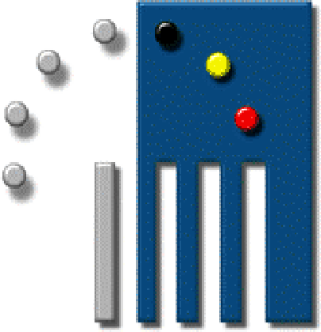



Program Meeting Follow Up Committee
20 November 2009

PONDSCAPE: Towards a sustainable management of pond diversity
at the landscape level (www.pondscape.be)

Venue: Small auditorium (level -1), Royal Belgian Institute of Natural Sciences, Vautierstraat 29, 1000 Brussels

Convenor: Dr Koen Martens (Coordinator)

Contact person: Els De Roeck
Telephone: 02/62 74 139
Email: els.deroeck@naturalsciences.be

13:00 – 14:00 Lunch (Wifi room)

14:00 – 14:10 Introduction to PONDSCAPE (K. Martens)

14:10 – 14:30 Tommelen case study (T. De Bie)

14:30 – 14:50 Pond management (E. De Roeck)

14:50 – 15:10 Microbial ecosystem functions (H.M. Cauchie)

15:10 – 15:30 Socio-historical survey (K. Morelle)

15:30 – 15:45 Coffee / tea break (Wifi room)

15:45 – 16:00 Pollutants in ponds (R. Mandiki)

16:00 – 16:20 Intermediate hosts of Fasciola hepatica (Y. Caron)

16:20 – 17:00 General discussion

